🛍️ Online Retail Transactions — Project Summary

Overview
This project explores a real-world dataset of online retail transactions from a UK-based store, focusing on customer behavior, purchasing patterns, and sales performance. The analysis was conducted using Python and Jupyter Notebook, leveraging Pandas, Matplotlib, and Seaborn for data cleaning, transformation, and visualization.

Objectives
- Clean and preprocess raw transactional data
- Identify key metrics: top-selling products, customer segments, and seasonal trends
- Visualize purchasing behavior and geographic distribution
- Prepare actionable insights for marketing and inventory decisions

Key Deliverables
- ✅ Cleaned dataset of 5,000+ transactions
- ✅ Interactive Jupyter Notebook with step-by-step analysis
- ✅ Visual dashboards highlighting:
  - Sales by country and product
  - Customer frequency and monetary value
  - Time-based trends and anomalies

Tools & Techniques
- Python: Pandas, NumPy, Matplotlib, Seaborn
- Jupyter Notebook: Reproducible, interactive analysis
- Excel: Raw and cleaned data comparison
- EDA & Segmentation: Exploratory Data Analysis and basic RFM modeling

Client Value
This project demonstrates my ability to turn messy transactional data into clear, actionable insights. It’s ideal for e-commerce businesses looking to understand customer behavior, optimize inventory, or improve marketing ROI.

🔗 GitHub Repository
Click here to view the full project

📊 Visual Preview
Top-Selling Products: Horizontal bar chart showing most frequently purchased items
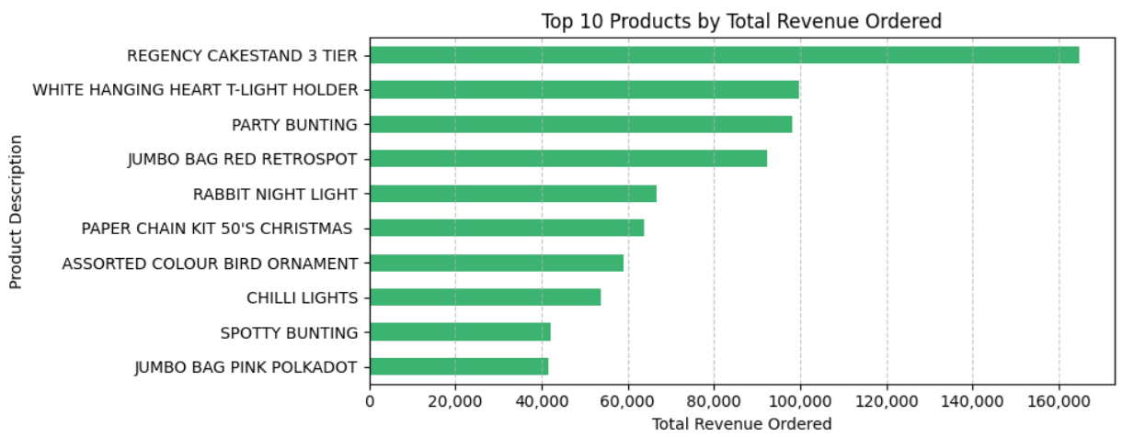

Sales by Country: Bar chart ranking countries by total revenue
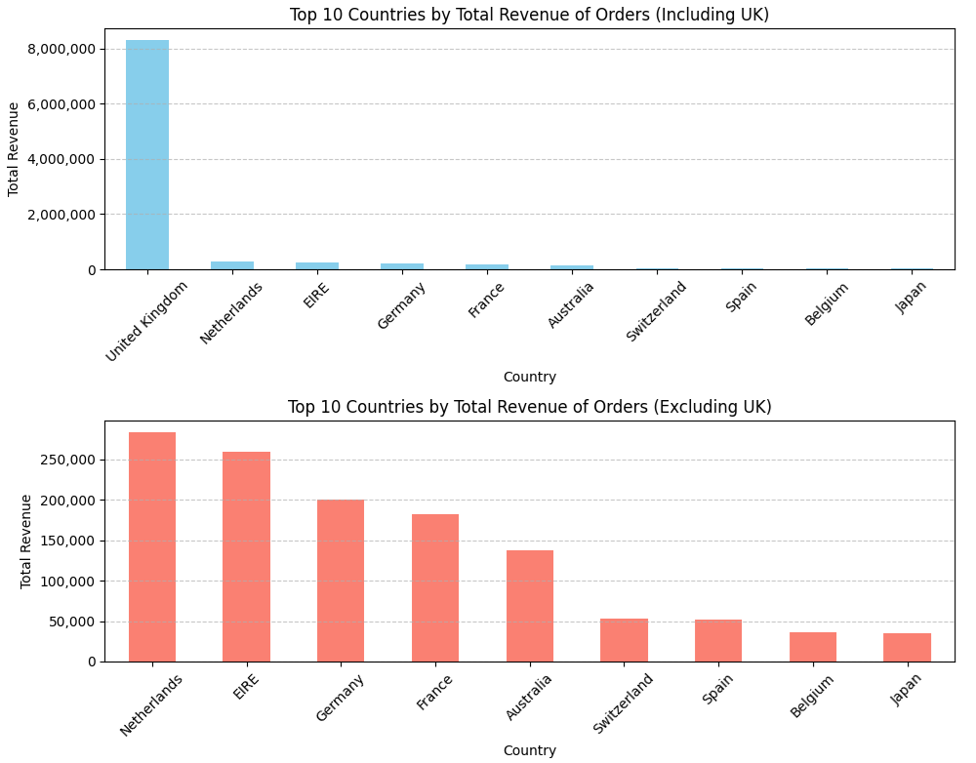

Monthly Sales Trends: Time series line chart showing revenue fluctuations across months
